Certification Data on LRC

https://reportcard.education.ohio.gov/

Enter your District in the Search box
Choose the district option to view the results on slide 4
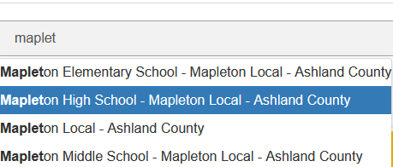
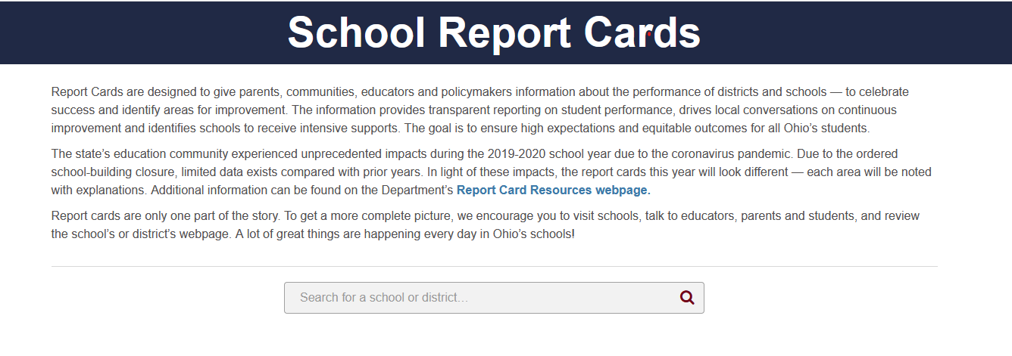

Select District Details
Then Scroll to view percentage

