**Pre-aSC**

**Things to do in DASL prior to extracting to aSc software**

**Future Year Scheduling**



**What information will come over into aSc from StudentInformation (SI or DASL):**

MCj04248280000[1]

aSc only pulls data from the Default Schedule.



1. Courses (except for Course Type = Blank)
2. Course Sections of course that have requests (see table below)
   1. Assigned Teacher
   2. Assigned Course Term
   3. Assigned Room
   4. How many periods section meets, but not which periods it meets

|  |  |  |
| --- | --- | --- |
| **Course Type in StudentInformation | Will sections come over into aSc if students have **requested** course in StudentInformation? | Notes: |
| Lunch | Yes |  |
| Vocational | Yes |  |
| ESC | Yes |  |
| Spare | Yes |  |
| Satellite | Yes |  |
| PSEO | Yes |  |
| Blank | No | *Course itself doesn’t come over either |
| Case Mgmt | Yes |  |
| Study Hall***** | **** | Study Hall sections will come over regardless if there are requests for the study halls or not |

1. Rooms that are marked as Is Schedulable in SI
2. Teachers
3. Any student with overall student status of “Active” (refer to Student Status table in SI)
   1. Student’s Grade level
   2. Student’s Course Requests
      1. Student’s Request priority (Low, Medium, High)

|  |  |
| --- | --- |
| StudentInformation Request Priority | Translates to what priority in aSc? |
| 1,2,3 | **Low** |
| 4,5,6 | **Medium** |
| 7,8,9 | **High** |
| n/a | **Strict**\* (use sparingly, must be done manually in aSc) |

**Things to do in StudentInformation before you load into aSc:**

1. Add any new teachers, rooms, courses, course terms and periods in SI. *Do not* add these in aSc, the schedule will error when you attempt to load it into SI. However, you can freely add new sections into aSc, the new sections will load into SI without any issue. Be careful adding sections in asc though. aSc lets you create sections without a teacher or a room assigned. When you go to print the student’s schedule in SI, important information like which room the class meets in or which teacher is teaching the class will be missing from the student’s printed schedule.

* Teachers
  + Remove any teachers from the 15/16 school year, you know will NOT be there, do this by deleting the job function of teacher in the 15/16 school year staff tab.
  + Add any new teachers that you know.
  + Staff/teacher updates will need to be done by EMIS Coordinator/District access

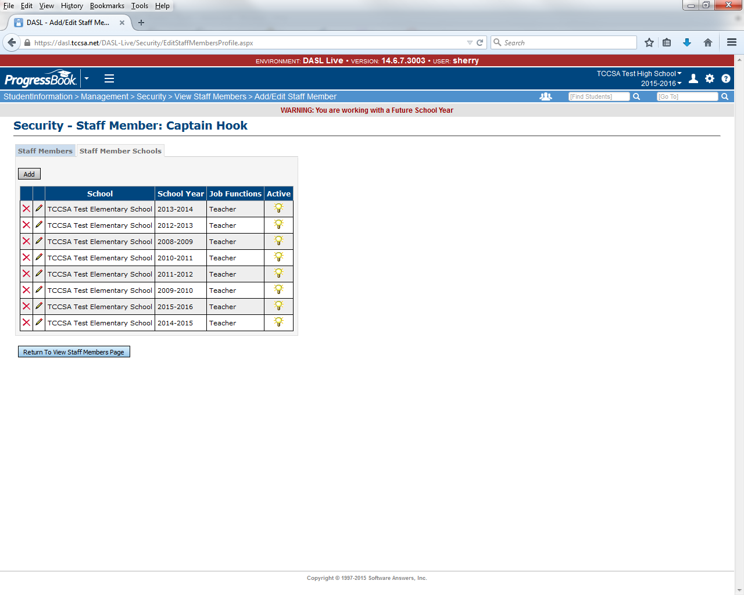

* Rooms/locations
  + Not school year specific, can add, but do not delete until current school year is finished. Verify that the Is Schedulable is checked.

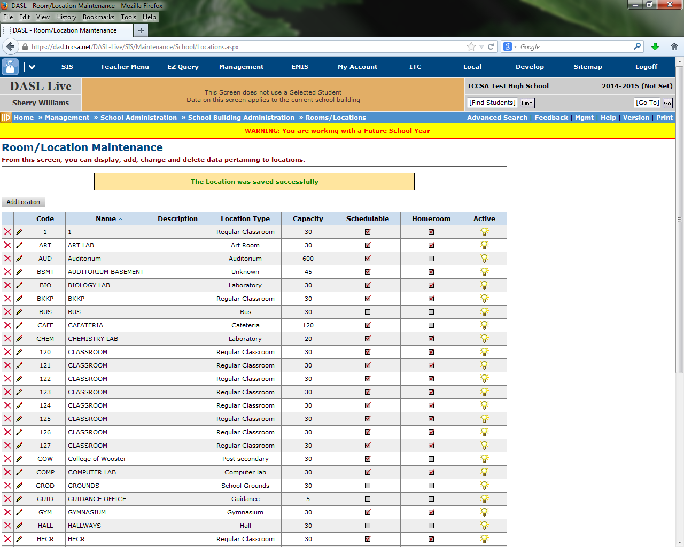

* Courses
  + Add any new courses needed
  + Delete any courses you no longer need
  + Change any course info you need to

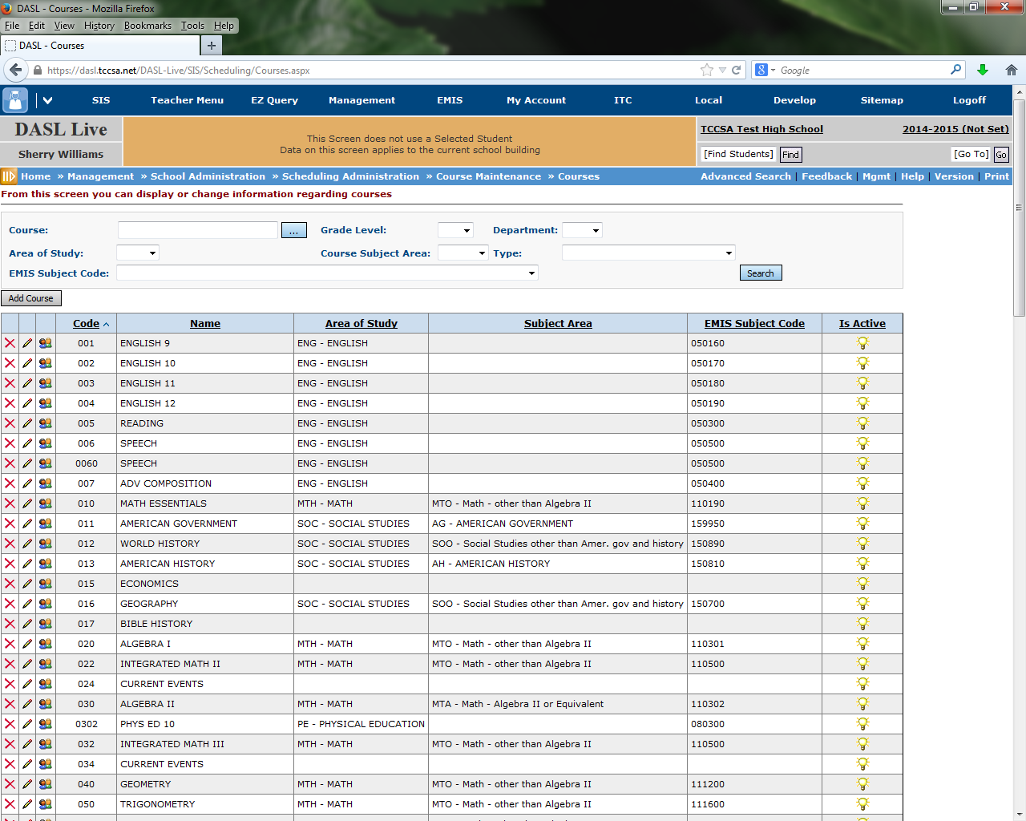

* Course terms
  + Verify the course terms are there that you need
  + Delete any extra course terms you don’t plan to use

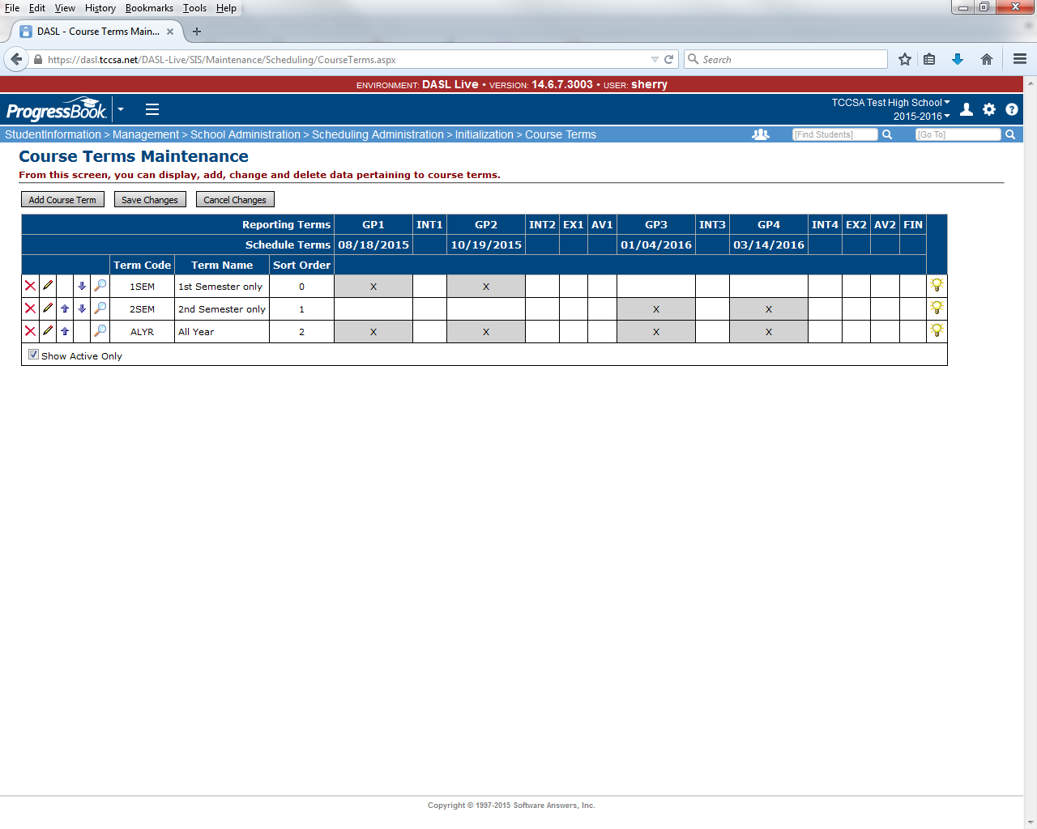

* Periods
  + Add new periods if needed
  + Delete ‘extra’ periods you don’t need, only do this right before loading to aSc. It is best to inactivate any periods in SI that aren’t part of the school’s typical day before you load into aSc. If you don’t inactivate the periods in SI and plan to block off the periods in aSc, this is will make the aSc scheduler run extremely long.

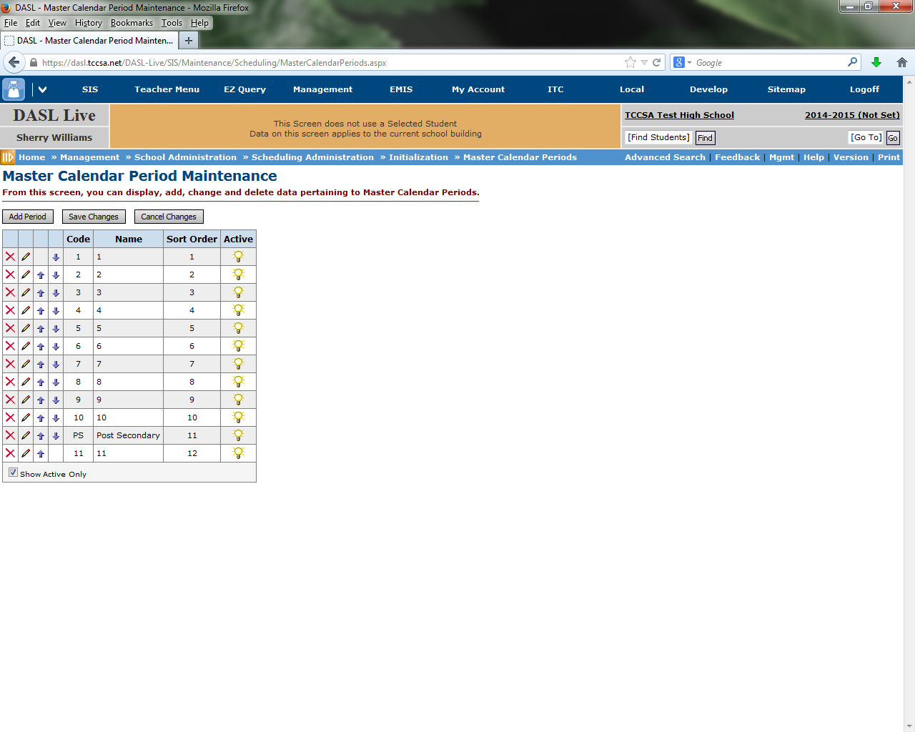

1. Finish promo/bulk enroll. Do not add new students directly into aSc, the integration back to SI will error when you attempt to load it. If you realize you are missing student(s), entire grade level, etc, it is best to go back into SI and redo promo/bulk enroll and then build a new schedule in aSc. Also, if you whack a student from SI after you’ve loaded data into aSc, you must also delete the student in aSc. Otherwise the import back into SI will fail.
2. Ensure course requests are entered in StudentInformation.

* All Requests MUST be in for the extract. Remember the program works to fill the most requests it can when creating the master schedule, so if all requests are not in, it will not create the best that it can for you.
* Once you start working with aSc, any new students can NOT be added, will need to do in DASL, once you import aSc schedule back to DASL
* Requests can be added directly in aSc after the extract from DASL – but you want to do as few this way as possible.
* Reports you may want to run to verify:
  + REQU – Students Course Requests
  + R402 – Tally Of Student Course Requests

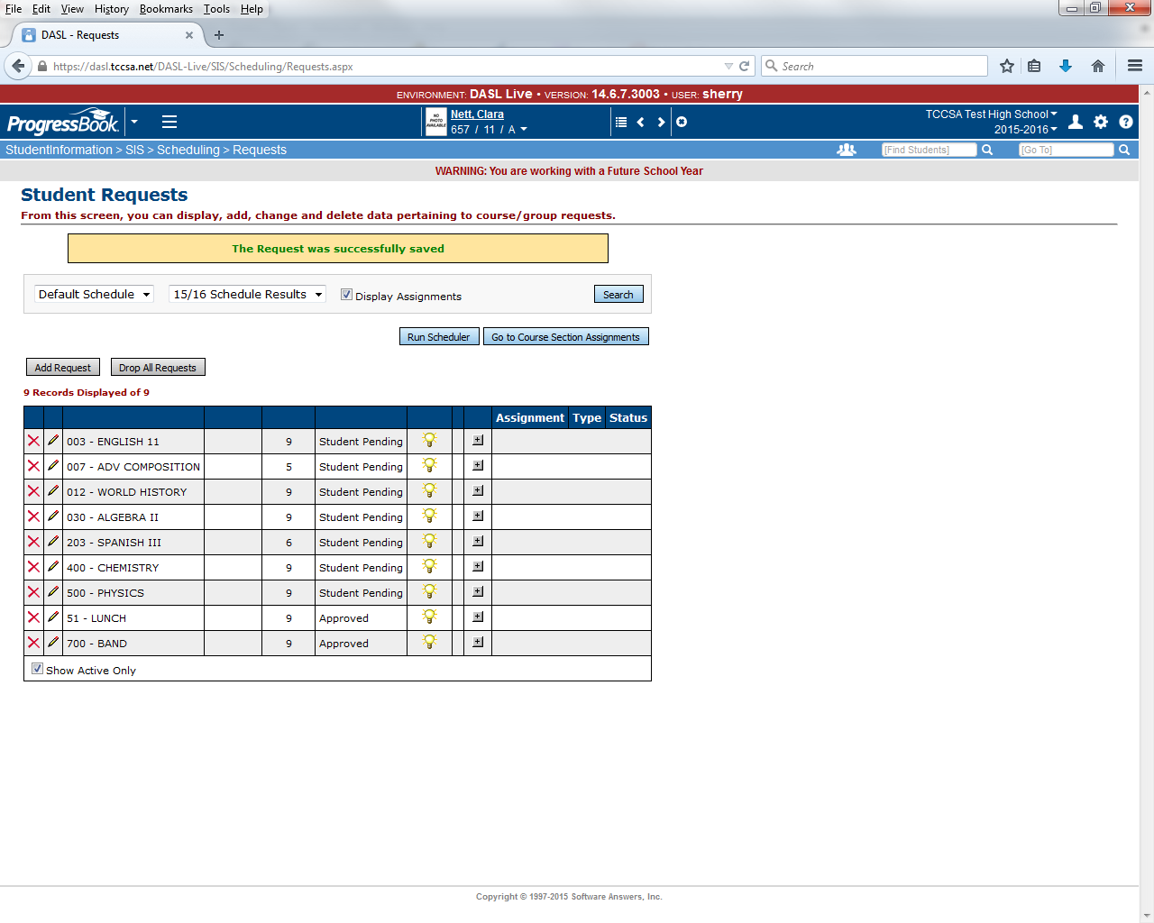

1. Ensure all course groups are setup correctly in StudentInformation have the IsLocked checkbox marked on tab 1 of the course group. SSST recommends not changing course groups in aSc.

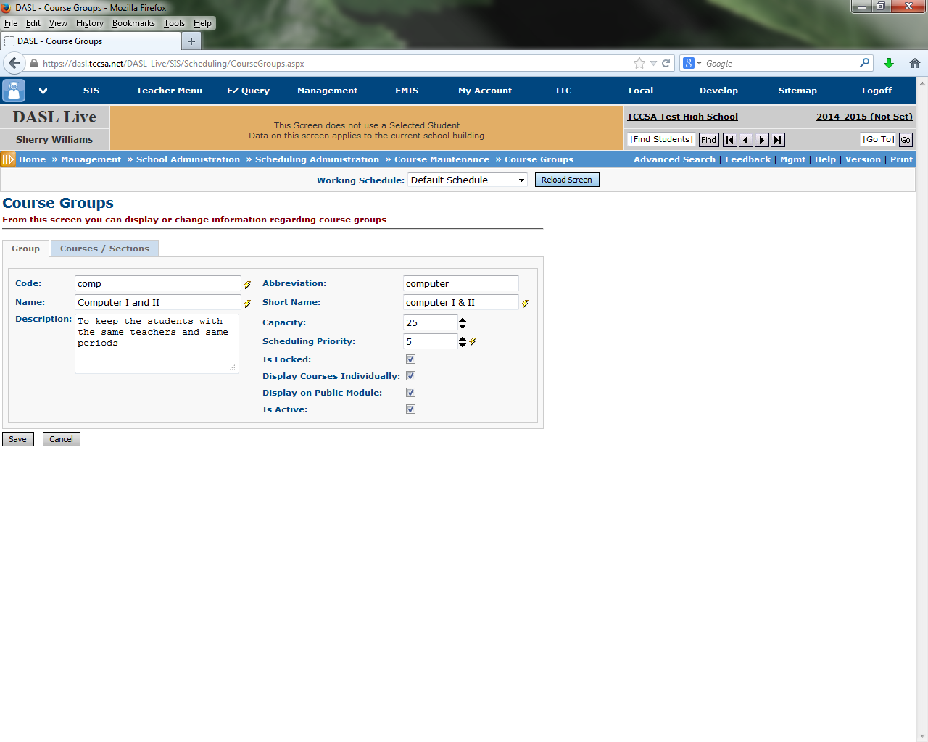

1. Determine shared teachers, rooms, & courses (run Teacher Schedule R411 with option checked to *Only Display Schedules For Teachers With Conflicts*) in SI before you load into aSc. These courses will need manually placed in aSc, it’s best to have a list ready. Example: Art teacher shared by MS and HS. Band teacher instructs 9,10,11,12 band during the same period. Please use the worksheet on page 12.
2. Verify the priority on the courses in SI are correct in Course Maintenance – Miscellaneous tab before loading into aSc. If you discover the priorities on the courses are wrong, after updating them you will need to submit a ticket asking that the student request priorities be updated. (Changing the priority in Course Maintenance doesn’t automatically trickle down to the requests already entered.) Check table above for aSc priority equivalents.

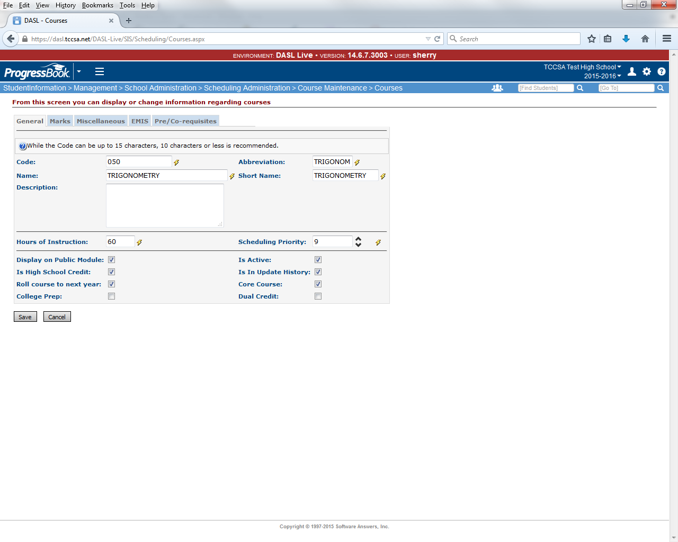

1. Make a list of courses that are “must haves” for the students, these are the courses that the rest of their schedule is built around. We will hand schedule the student’s into these courses. Example: Sally must have Pre-calc 5th period, the rest of her schedule can be determined by the scheduler.
2. Verify section capacities are correct in SI. aSc doesn’t have an option to overfill sections like the SI scheduler does. You can run the R407 in SI and R402 – Tally of Course Requests. Use the report data to determine which sections you need to add capacity to or which courses need additional sections added. Inactivate sections you don’t need any more (Example: Freshman class is smaller than last year and only 3 sections of PE are needed, not 4). Finally, remove any student requests that aren’t needed in SI.
   1. Remove unneeded sections
   2. Add sections
   3. Increase section capacity

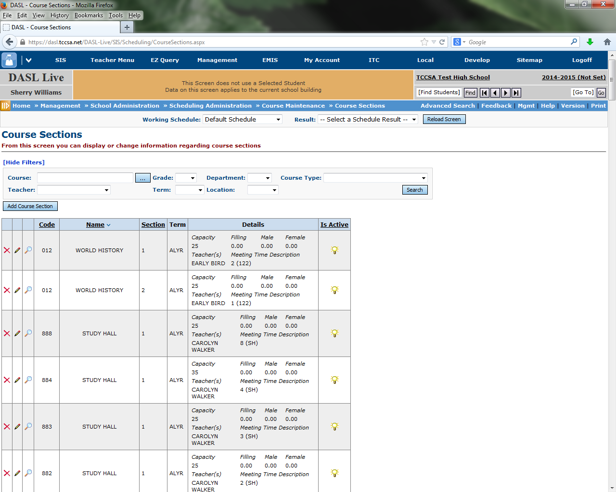



1. **New for 14/15 scheduling:** Change all courses without requests (Study Halls, PSEO, Special Ed, etc) to course type PSEO (as an example) in SI. These sections will not come over into aSc since they don’t have requests. Once scheduling is complete in aSc and schedule is loaded into StudentInformation please send a ticket to your ITC to have the PSEO sections copied from the original schedule into the aSc schedule you have loaded into SI.

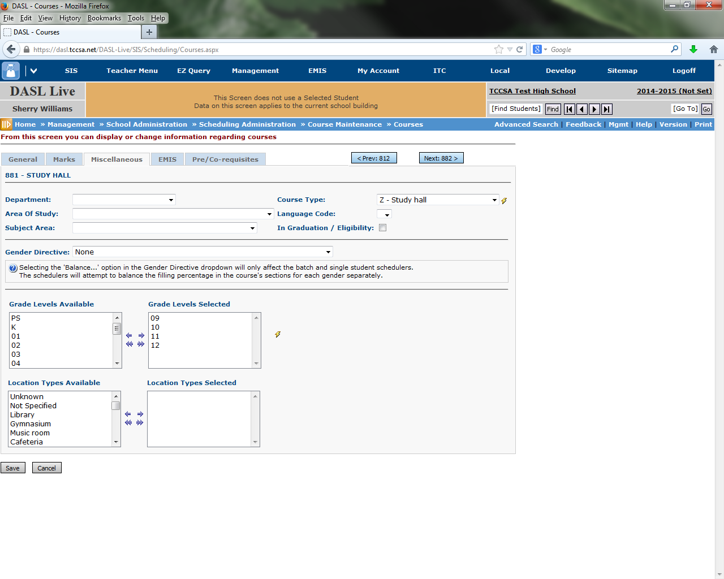

1. Determine when lunch is offered and enter requests for Lunch if you want the aSc scheduler to schedule lunch.
2. Make a list of courses that can be offered either:
   1. 1st Semester or 2nd Semester
   2. 1st 9 Weeks or 2nd Weeks or 9 Weeks or 3rd 9 Weeks or 4th 9 Weeks
   3. 1st Tri or 2nd Tri or 3rd Trim
   4. 1st 6 Weeks or 2nd 6 Weeks or 3rd 6 Weeks or 4th 6 Weeks or 5th 6 Weeks or 6th 6 Weeks
3. Determine any course sequencing rules or Teacher Link Groups. (Speech 1 has to be in a term before Speech II)

MC900250392[1]

Helpful Hint: Clean up as much as you can in StudentInformation. Why?

* Because if you have to “start over” and build a new schedule in aSc, the data you fixed in StudentInformation will come over to aSc when you reload.
* It will make things easier to use an environment you are familiar with

**Scheduling Worksheet**

**Teachers who are aren’t there the entire school day:**

(example: Band Teacher who is at Middle School in the AM, High School in the PM)

|  |  |
| --- | --- |
| Teacher Name | Which periods are they gone? |
|  |  |

**Courses / Teachers / Rooms that are double scheduled:**

(example: Art 2, Art 3, Art 4 all taught the same period by Art teacher in the Art room)

|  |  |  |
| --- | --- | --- |
| Teacher Name | Courses | Classroom |
|  |  |  |

**Course Sequencing Rules / Teacher Link Groups:**

|  |  |
| --- | --- |
|  |  |

**Lunch Period(s) – Should lunch print on student schedules?**

|  |  |
| --- | --- |
| Lunch Period(s) | Print on schedule? |
|  |  |

**Courses that can be scheduled in either term:**

Example: Keyboarding can be Sem1 or Sem2

|  |  |
| --- | --- |
| Course | Term |
|  |  |

**List of students & their courses that the student’s schedule should be built around:**

|  |
| --- |
|  |

**Courses that have to meet certain periods:**

Example: Band is 7th period, Choir is 5th

|  |  |
| --- | --- |
| Course | Period |
|  |  |

**Appendix B: How to schedule all teachers within a certain department into the same planning period**

1. Before you pull into aSc, create a course named Planning Period in StudentInformation in 15/16. This new course can be any course type except Blank.

If you want the aSc system to come up with planning periods for your staff in groups, create the above course as mentioned in DASL. The rest of this will be done in aSc.